St. Michael’s Fall Retreat

7 Virtues Focus
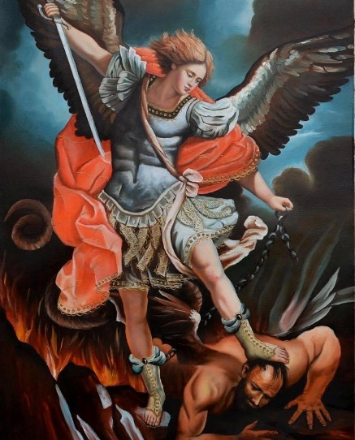
Open to all Catholic boys in the Diocese grades 3-8

Where: St. Augustin’s school and school chapel
When: Saturday, November 4, 8 am – 6 pm
(Ending with 5 pm vigil Mass)
Led by H.S. boys and local priests
Cost: $50 day retreat (scholarships available)
Fun Activities, Games, and Talks

Register by Monday October 30
Registration limited to 35 boys
Contact kmpierick@gmail.com or
Jeff Pierick 515-778-6087

