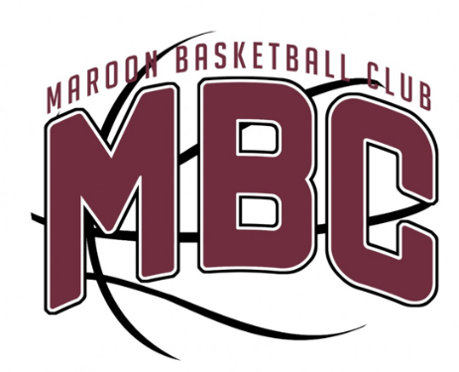

What is the Maroon Basketball Club?
- A girls youth basketball program to teach girls basketball fundamentals and develop their skills through a controlled and safe environment. All girls will be placed onto a team appropriate to their current skill level. Once a team is set, coaches will communicate which leagues, tournaments and other opportunities are available for the age group.
Who can join the Maroon Basketball Club?
- All girls going into 2nd-8th grade of the 2023/2024 school year.
Is this a tryout team?
- Yes, there will be tryouts. HOWEVER, every effort will be made to find a team for all girls appropriate for their skill level.
When are tryouts?
- Tryouts will be held on July 10, 2023 at the Dowling Catholic Gym. We know managing schedules is a challenge and will have a make-up tryout date on July 18, 2023 at St. Francis of Assisi Gym.
Who are the coaches?
- Coaches will mainly consist of parent volunteers; however, we are working with members of the Dowling Girls Coaching Staff as well as current and former players on assisting with coaches’ clinics and potential practices to share philosophy, demonstrate drills and other fundamentals skills to work on. There may also be the opportunity for some teams to have paid coaches.
How do I sign up?
- Please sign up for tryouts here: https://forms.gle/HL9nzeYF9YqQAVp68

Other Questions?
- Please direct all questions to any of the Maroon Basketball Club Board Members
  - Greg Hayes (ghayes@ironhorsewm.com)
  - Emily Muehling (Emily.Muehling@unitypoint.org)
  - AJ Muehling (AMuehling@athene.com)
  - Amy Roberts (amy.roberts@dalecarnegie.com)
  - Tocia Hanna (tocial1104@gmail.com)
  - Michelle Franzen (michellefranzen12@gmail.com)

