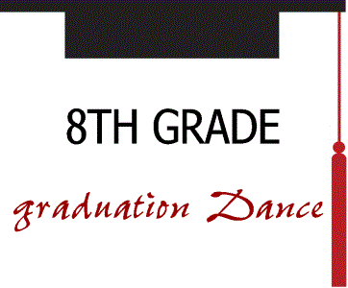

When: Saturday, May 18, 2019 from 7:00 to 9:00 PM

Where: St. Theresa Community Center (Gym). Enter from the south side school doors

Cost: $7.00 which includes pop tickets, the dance, Music, and Wii games set up, photo booth (extra pop and food can be purchased at additional cost)

Who: All 8th grade students from the Des Moines Area Diocesan schools

Why: A special event to congratulate you upon your graduation from 8th grade and to add another
special memory of your time in middle school: so dress up in your Graduation outfit.

Other guidelines for outfits
Ladies: modest dress that is appropriate in length and has straps wider than one inch. Dresses cannot be strapless. Wraps are recommended to be worn to cover up shoulders.

Young Men: slacks, khakis are appropriate, no shorts. Polo style, button downs, sweaters, fleece are acceptable.

Sponsor: St. Theresa’s Youth Ministry
(call Megs at 515-720-4060 for more information)

Additional Information: There will be numerous chaperones and a police officer will be on hand for the entire
evening. Cell Phones will be checked at the door.

