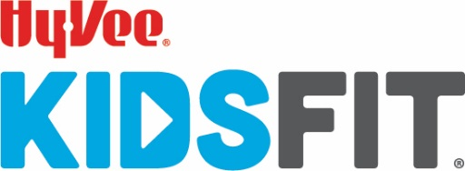

Hello Families!

It was great visiting your community! It is important to have a community supporting the importance of movement and motivation for students. Last Friday, your students completed Partner Challenges, Team Challenges and Individual Challenges. Help continue personal growth and responsibility.
Please help your student sign-up for the FREE 5-Week Challenge at www.hy-veekidsfit.com or the Hy-Vee KidsFit App. The 5-Week Challenge is one healthy conversation or activity per day. The Website and App are to be a safe place for kids to engage with helpful tips and fun activities that encourages movement and learning.
It takes us all doing our best to make those around us better. Our best can impact our classes, school, families and ultimately our COMMUNITIES! The West Des Moines Hy-Vee HealthMarket is excited to help in a small way by offering the students an in-store PRIZE for continuing these challenges. Once your student completes a blackout on the BINGO card (attached), visit Ashley, the in-store Dietitian at the Hy-Vee HealthMarket to claim a prize!
Through the website and app we cannot push any information out to you. To stay updated on new information, challenges & kids approved recipes from our Hy-Vee Dietitians, please follow us on our social media platforms. Go “Like” and “Share” with your friends!
- Hy-Vee KidsFit on Facebook
- Instagram at @hvkidsfit
- Twitter @Hy-Vee KidsFit.
- West Des Moines Hy-Vee HealthMarket on Facebook

Daira Driftmier Ashley Danielson, RDN, LD
Hy-Vee KidsFit, Hy-Vee Fitness, Director Registered Dietitian
CPT, Youth Fitness Specialist WDM Hy-Vee HealthMarket
Hy-Vee, Inc. | 5820 Westown Parkway | WDM, IA 50266 375 S. Jordan Creek Parkway | WDM, IA 50266
e: ddriftmier@hy-vee.com e: aldanielson@hy-vee.com

