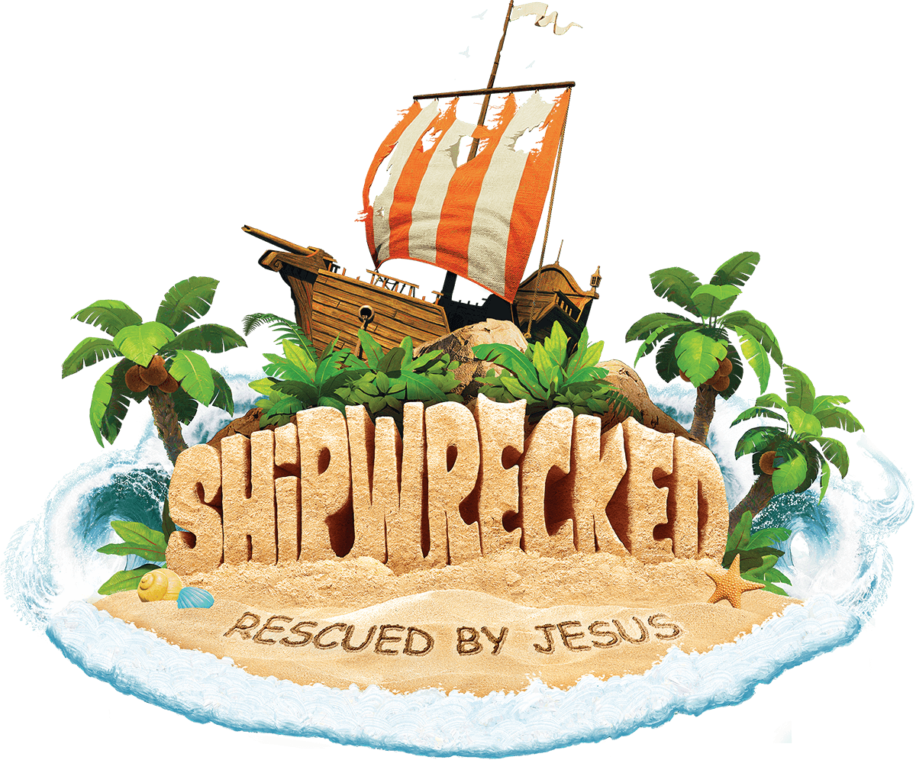
We ARE Having VBS This Summer!

St. Francis of Assisi has a VBS Coordinator and a good start on an adult volunteer list so VBS will be offered this summer!

Save the Date!
Vacation Bible School
June 11-15, 2018 - 9am – Noon
for 4 year olds through
children entering 6th grade.

New this year – Online Registration! Registration for participants and youth volunteers will begin on April 16, 2018. Look for more information to come soon!

If you have a child with special needs that you plan on registering for VBS, please contact the Faith Formation Office. We want to get an early jump on our plans to make sure all needs are meet during this fun week!

We are still taking ADULT VOLUNTEERS. If you are willing to volunteer for VBS, please contact the Faith Formation office soon by calling 515-440-1030.

