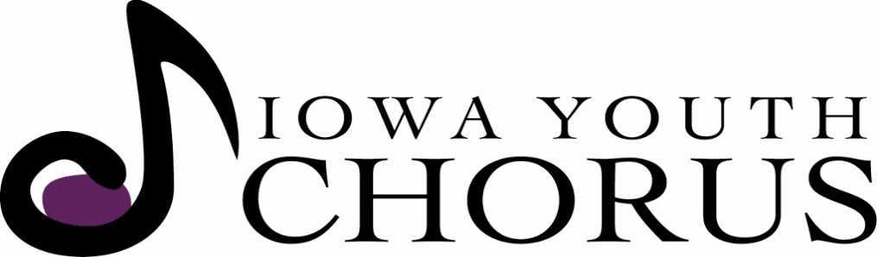
Raising Iowa’s Future Voices -

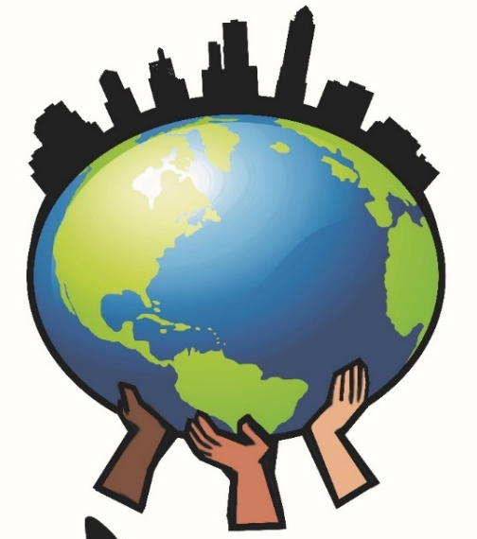
Sing
Local!
Think
Global!

Back to Choir Night is Sunday, Sept. 10 at 4:30 – 7:00 pm at Wesley Acres Court Yard RSVP or e-mail info@iowayouthchorus.org for questions or more information

- Four Choral Opportunities: Singers Ages 6 – 18
  - All are welcome to join regardless of previous singing experience
  - No Auditions required!

- Scholarships Available
  - Music Activity Fee is $15 for students receiving scholarships
  - Tuition can be reduced by 15%-90% for those who apply and qualify

- Multiple Discounts such as: Early Bird, Sibling, & Paid in Full
  - Check our website for deadlines and information about these special offers!
- Open & Free Rehearsals: September 10 – 29
  - Come find your place in the choir!

- Social Activities for Choristers & Families!
  - Back to Choir Night, Harvest Party, Bring a Friend, Caroling and more!

- Touring Opportunities
  - Past Tours include New Orleans, Italy and Colorado

- No Fundraising Requirements
  - We just want you to sing!
Iowa Youth Chorus | 3520 Grand Ave. | Des Moines, Iowa 50312 | www.IowaYouthChorus.org
Iowa Youth Chorus
Metro Rehearsal Times & Locations:
Primary Choir, Children’s Chorus & Concert Choir Rehearsals
start the week of September 10

Primary Choir ~ 1st – 2nd Grade Singers
Mondays ~ 5:00 – 5:45 pm Tuesdays ~ 5:15 – 6:00 pm
Ankeny United Church of Christ Wesley Acres Mansion 602 SE Deleware Ave, Ankeny 3520 Grand Avenue, Des Moines

Children’s Chorus ~ 3rd – 5th Grade Singers
Mondays ~ 5:45 – 6:45 pm Tuesdays ~ 6:15 – 7:15 pm
Ankeny United Church of Christ Wesley Acres Mansion 602 SE Deleware Ave, Ankeny 3520 Grand Avenue, Des Moines

Thursdays ~ 5:45 – 6:45 pm
Capitol Hill Lutheran Church in the Sanctuary; 511 Des Moines Street, Des Moines

Concert Choir Chamber Singers*
(5th – 9th Grade Treble Singers) (8th – 12th Grade SATB Choir)
Thursdays ~ 6:45 – 8:15 pm Sundays ~ 1:30 – 4:30 pm
Capitol Hill Lutheran Church in the Sanctuary Wesley Acres, Community Room
511 Des Moines Street, Des Moines 3520 Grand Avenue, Des Moines

* Chamber Singers start Sunday, August 27
Iowa Youth Chorus is a Non-Profit Organization based in Des Moines, Iowa that currently serves over 150 choristers. We offer multiple rehearsal locations and times throughout the metro area in addition to outreach choirs in Pella, Newton and Ankeny!
We invite you to come to our open rehearsals offered in September and January. No registration is required and are free to attend. All singers welcome!
New Chorister Early Bird Deadline is September 15; Choir Registration Deadline is September 29
“This is not a Des Moines Public Schools activity. The district shares this information as a courtesy to create awareness of community opportunities available to our students and their families.”
Questions about IYC: 515.262.8312 or iowayouthchorus.org

