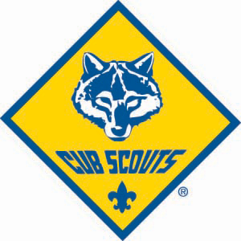

INTERESTED IN BECOMING A CUB SCOUT?
COME LEARN ABOUT SFA PACK 88

Boys in grades K-4th and their families are invited to attend the Pack Picnic
5/24/2017 at Campbell Park, Clive IA From 6-8pm
Scout activities include pinewood derby, campouts with friends, SFA parish and community involvement, exploring new places and learning lifelong skills.

FOR DETAILS CONTACT: Charlie Bottenberg at cbottenberg@dsmlawyers.com

For additional information on Cub Scouting, go to www.cubscouts.org and www.midiowacouncilbsa.org for information on your local council.
